Game Loops
Core Loop
“At the heart of your game’s design, there are core mechanics, and the core gameplay loop. In short, it’s the main activities that structure the entire design and the players engage into repeatedly, in a looping sequence.” (Lovato, 2017).
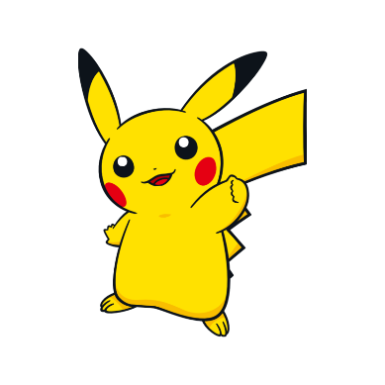
A great example of the core loop would be Pokemon which the player explores, encounters, collects, levels, and upgrades Pokemon rinse and repeat. A well thought out loop to keep the players experience of the game fresh throughout the entire main and post-game. There other types of loops such as level design loop, what the player must do to move forward giving a sense of progress. Game loops, the players mid or long-term goals are such as beating a level or the end-game boss.
“The more the player has to go through the loop, the more its quality will affect your game’s retention. On mobiles or on the web, if the main mechanics aren’t intuitive, the controls not polished, you’ll lose them within a minute or two. People will give you a single chance to entertain them.”
The core loops are the foundation of the games design, something the player will experience on throughout the entire game repeatedly.
- Level Design Loop
Stealth (short-term) → Explore (mid-term) → Collect (long-term)
Stealth, bypass the Shogun’s Shikigami (Samurai birds) unnoticed. Explore, search around the Shogun’s castle to enter new places to reach bosses room. Collect, pick up new items (keys) to unlock new areas in the level to progress into the game.
- Game Loop:
Stealth (short-term) → Assassinate (mid-term) → Rescue (long-term)
Stealth, passing by the Shoguns Samurai (Shikigami) obstacles unnoticed to reach the general or Shogun’s room. Assassinate, kill the Shogun’s military Generals after completing boss room requirement to progress forward. Rescue, save your villager children after defeating the boss room.
Feedback Loops
There are two kinds of feedback loops, positive feedback loops and negative feedback loops.
“A positive feedback loop can be thought of as a reinforcing relationship. Something happens that causes the same thing to happen again, which causes it to happen yet again, getting stronger in each iteration – like a snowball that starts out small at the top of the hill and gets larger and faster as it rolls and collects more snow.” (Learn.Canvas, 2013).
In
References:
Lovato, N. (2017). How to Perfect your Game's Core Loop - GameAnalytics. [online] GameAnalytics. Available at: https://gameanalytics.com/blog/how-to-perfect-your-games-core-loop.html [Accessed 6 Feb. 2018].
Fitzpatrick, K. (2016). Gotta Fuck ‘Em All. [online] 1234kyle5678.com. Available at: http://1234kyle5678.com/wp-content/uploads/2016/09/Pikachu-poke%CC%81mon-go-fucke%CC%81mon-go-men.com-peek-a-choo-gay-porn-parody-xxx-1234kyle5678.png [Accessed 6 Feb. 2018].
Learn.canvas (2013). Level 4.4: Feedback Loops: Game Design Concepts. [online] Learn.canvas.net. Available at: https://learn.canvas.net/courses/3/pages/level-4-dot-4-feedback-loops [Accessed 6 Feb. 2018].

